DAY 3 – Evening Handson

1. Insert Operations
Q1. What is the purpose of insertOne() in MongoDB?
Answer:
insertOne() is used to insert a single document into a MongoDB collection. It is useful when we want to add only one record at a time.

Q2. Write a MongoDB command to insert a single document into a collection.
Answer:
db.users.insertOne({ name: "Daksh", age: 22, country: "INDIA" });

Q3. How does MongoDB behave if the collection does not exist while using insertOne()?
Answer:
If the collection does not exist, MongoDB automatically creates the collection and then inserts the document. No error is generated.

Q4. What is insertMany() and how is it different from insertOne()?
Answer:
insertMany() is used to insert multiple documents at the same time, whereas insertOne() inserts only one document.
Example:
db.sports.insertMany([
{ name: "Daksh", age: 20 },
{ name: "Shrey", age: 22 }
]);

Q5. What happens if one document fails during insertMany() execution?
Answer:
By default, MongoDB stops inserting further documents when an error occurs. Documents inserted before the error remain saved.
This behavior can be changed using the ordered:false option.

2. Update Operations
Q1. What is the difference between updateOne() and updateMany()?
Answer:
- updateOne() updates only the first matching document.
- updateMany() updates all documents that match the filter condition.

Q2. Write a command to update only one document’s field in MongoDB.
Answer:
db.sports.updateOne(
{ name: "Daksh" },
{ $set: { age: 26 } }
);

Q3. How do you update multiple documents at the same time in MongoDB?
Answer:
By using updateMany().
db.sports.updateMany(
{ country: "India" },
{ $set: { status: "Active" } }
);

Q4. What happens if the filter condition in updateOne() matches multiple documents?
Answer:
Even if multiple documents match, only the first matching document is updated.

Q5. What update operator is used to modify specific fields without replacing the entire document?
Answer:
The $set operator is used to modify specific fields without replacing the whole document.

3. Add Date (Current Date)
Q1. How do you add the current date to a document while inserting data?
Answer:
db.users.insertOne({
name: "Daksh",
joinedDate: new Date()
});

Q2. Which MongoDB operator is equivalent to SQL CURDATE()?
Answer:
MongoDB uses new Date() or $currentDate, which is equivalent to SQL CURDATE().

Q3. Write a command to add the current date to all existing documents.
Answer:
db.sports.updateMany(
{},
{ $currentDate: { updatedDate: true } }
);

Q4. What is the difference between using new Date() and $currentDate?
Answer:
new Date() | $currentDate
Used while inserting or updating | Used only during update
Date value is set manually | MongoDB sets the date automatically
Stored as a value | Stored as a system-generated date

4. Delete Operations
Q1. What is the difference between deleteOne() and deleteMany()?
Answer:
- deleteOne() deletes only one matching document.
- deleteMany() deletes all matching documents.

Q2. Write a MongoDB command to delete a single document.
Answer:
db.sports.deleteOne({ name: "Daksh" });

Q3. What happens if the filter in deleteMany() is empty {}?
Answer:
If the filter is empty, all documents in the collection are deleted, but the collection itself remains.

5. Drop Operations
Q1. How do you drop a collection (table) in MongoDB?
Answer:
db.users.drop();
This removes all documents and the collection itself.

Q2. What is the command to drop an entire database in MongoDB?
Answer:
db.dropDatabase();

Q3. What is the difference between deleteMany({}) and drop()?
Answer:
deleteMany({}) | drop()
Deletes all documents | Deletes documents + collection
Collection remains | Collection is removed
Slower | Faster

Practical Questions
1. InsertOne (Practical)
Q1. Insert a student record with name, course, and year.
db.students.insertOne({ name: "Daksh", course: "Sports Science", year: 2025 });
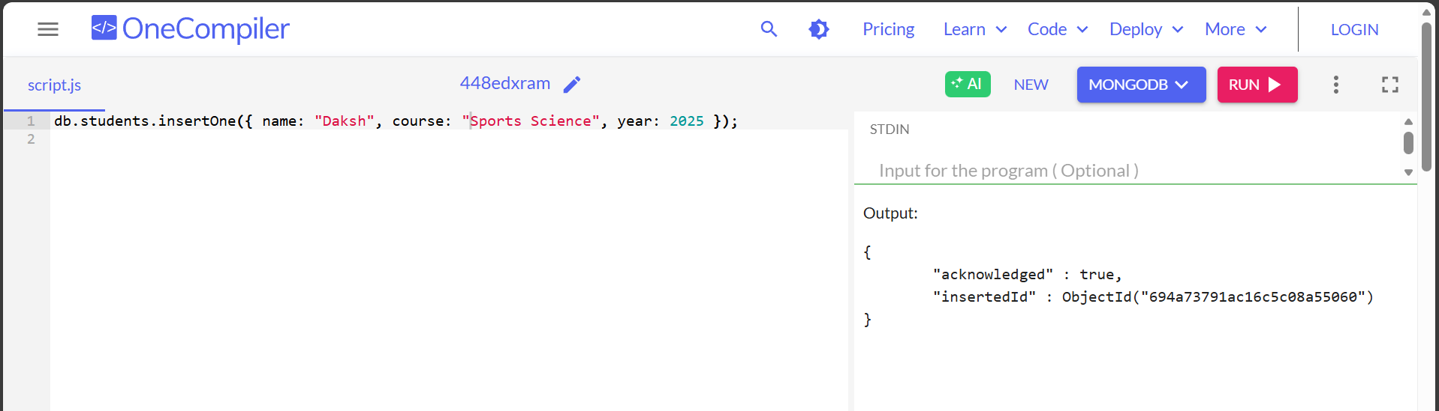

Q2. Insert an employee document with name, role, salary, and joining date.
db.employees.insertOne({
name: "Shrey",
role: "Sports Analyst",
salary: 45000,
joiningDate: ISODate("2023-06-01")
});
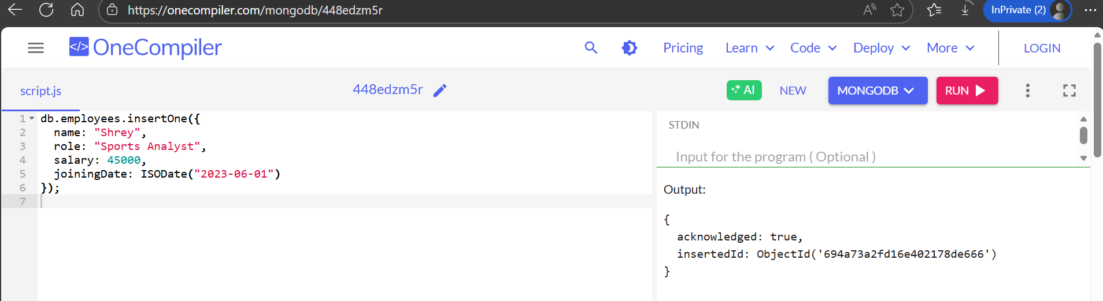

Q3. Create a product document with name, price, and category.
db.products.insertOne({
name: "Cricket Bat",
price: 3500,
category: "Sports Equipment"
});
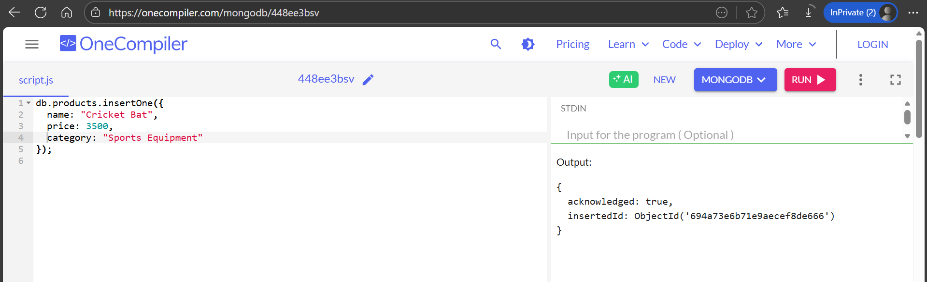

2. InsertMany (Practical)
Q4. Insert at least 5 user records into a collection.
db.users.insertMany([
{ name: "Daksh", age: 21, sport: "Cricket" },
{ name: "Shrey", age: 22, sport: "Football" },
{ name: "Aarav", age: 20, sport: "Basketball" },
{ name: "Rohan", age: 23, sport: "Tennis" },
{ name: "Kunal", age: 21, sport: "Badminton" }
]);
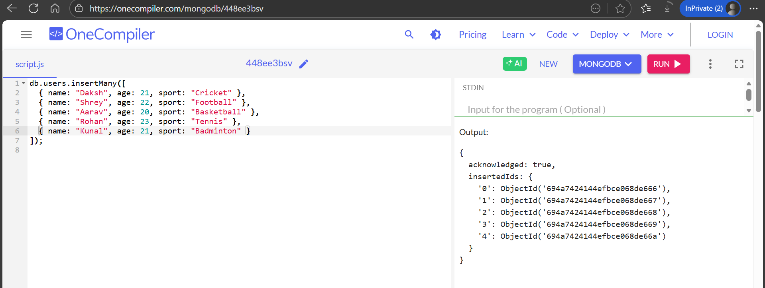

Q5. Insert multiple products belonging to different categories.
db.products.insertMany([
{ name: "Football", price: 1200, category: "Sports Equipment" },
{ name: "Running Shoes", price: 2800, category: "Sports Wear" },
{ name: "Tennis Racket", price: 4500, category: "Sports Equipment" }
]); 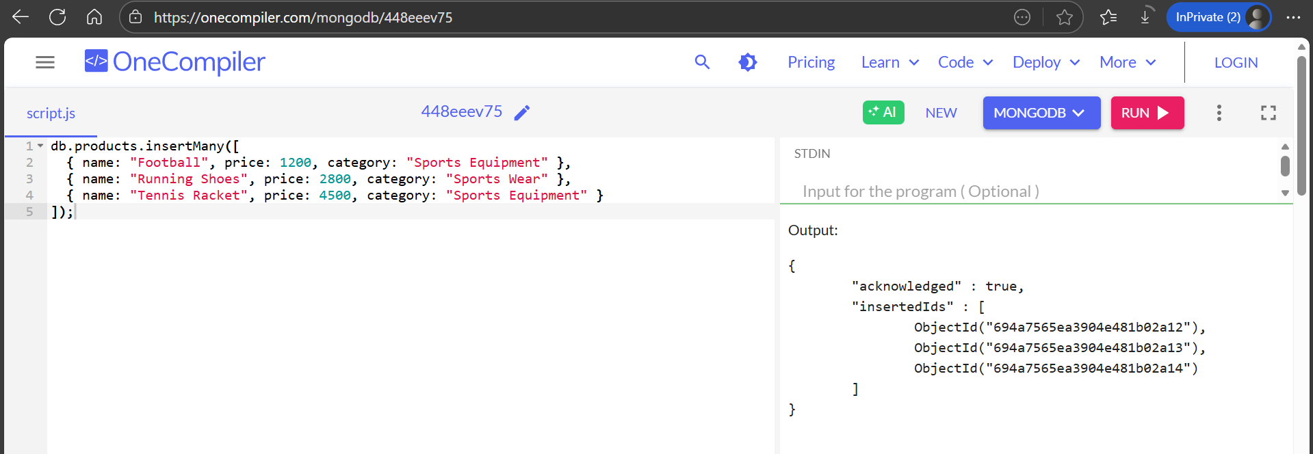

Q6. Insert many orders with orderId, customerName, and totalAmount.
db.orders.insertMany([
{ orderId: 101, customerName: "Daksh", totalAmount: 5000 },
{ orderId: 102, customerName: "Shrey", totalAmount: 3200 },
{ orderId: 103, customerName: "Aarav", totalAmount: 4500 }
]);
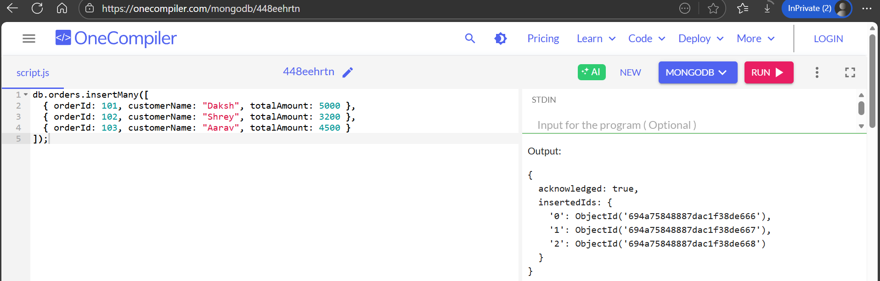
3. UpdateOne (Practical)
Q7. Update the salary of a single employee.
db.employees.insertOne({
name: "Shrey",
role: "Sports Coach",
salary: 38000
});
db.employees.updateOne(
{ name: "Shrey" },
{ $set: { salary: 50000 } }
);
db.employees.find({ name: "Shrey" }).pretty();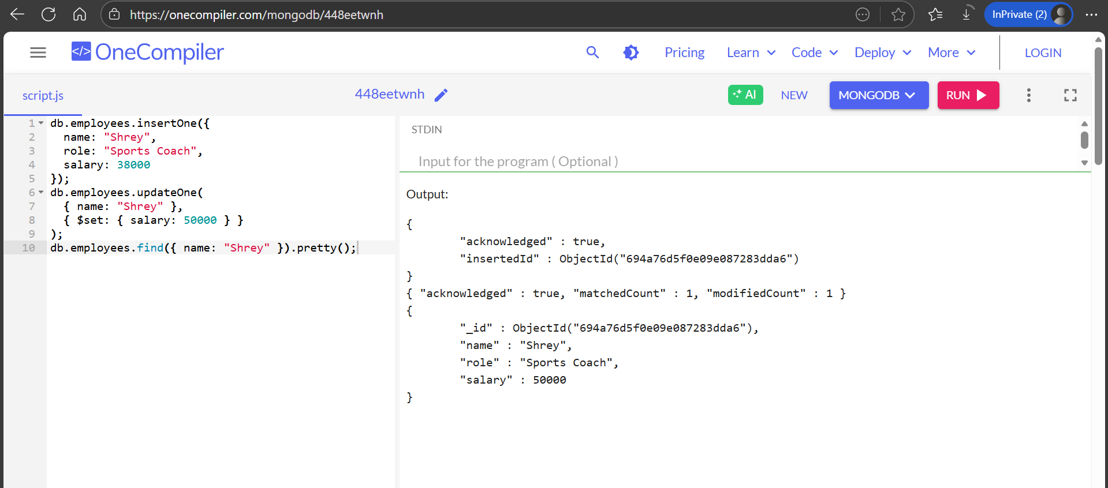
Q8. Add a new field status to one specific user.
db.employees.insertOne({
name: "Shrey",
role: "Sports Coach",
salary: 38000
});
db.employees.updateOne(
{ name: "Shrey" },
{ $set: { salary: 50000 } }
);
db.employees.updateOne(
{ name: "Shrey" },
{ $set: { status: "Active" } }
);
db.employees.find();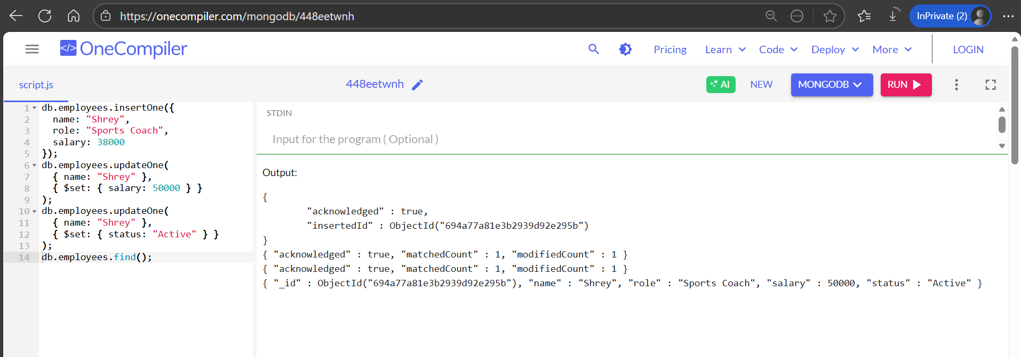
Q9. Change the city of one customer.
db.orders.insertOne({
orderId: 201,
customerName: "Daksh",
totalAmount: 4500,
city: "Delhi"
});
db.orders.updateOne(
{ customerName: "Daksh" },
{ $set: { city: "Mumbai" } }
);
db.orders.find({ customerName: "Daksh" }).pretty();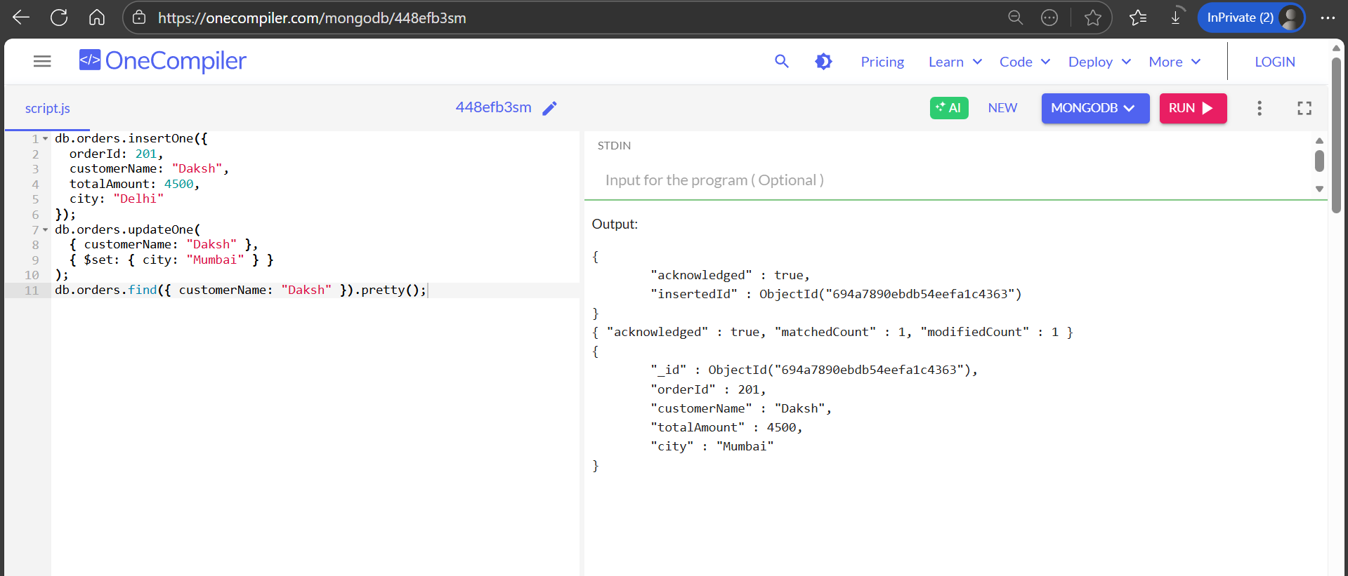
4. UpdateMany (Practical)
Q10. Add a field updatedDate with the current date to all records.
db.users.insertMany([
{ name: "Daksh", sport: "Cricket", age: 21 },
{ name: "Shrey", sport: "Football", age: 22 },
{ name: "Aarav", sport: "Basketball", age: 20 }
]);
db.users.updateMany(
{},
{ $currentDate: { updatedDate: true } }
);
db.users.find().pretty();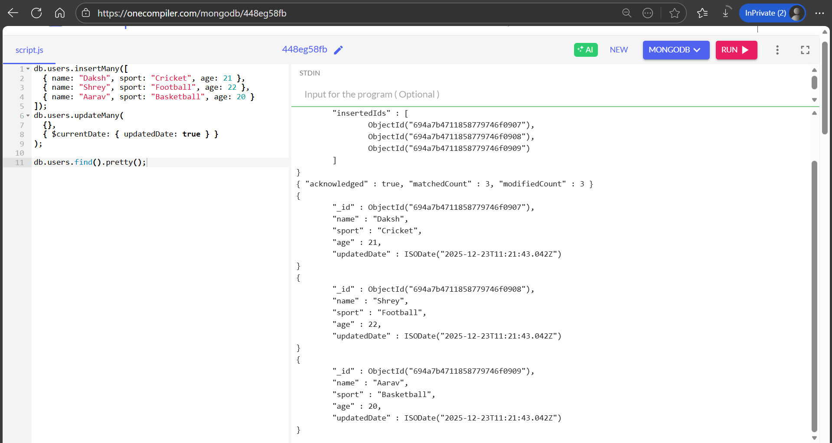

Q11. Increase the price of all products in a specific category.
db.products.updateMany(
{ category: "Sports Equipment" },
{ $inc: { price: 500 } }
);

Q12. Add a new field country to all users.
db.users.updateMany(
{},
{ $set: { country: "India" } }
);

5. Add Date (Practical)
Q13. Insert a document with the current date using MongoDB.
db.matches.insertOne({
match: "Cricket Final",
matchDate: new Date()
});

Q14. Update all documents by adding today’s date.
db.matches.updateMany(
{},
{ $currentDate: { updatedOn: true } }
);

Q15. Convert a numeric year field into a date field.
db.students.updateMany(
{ year: 2024 },
{ $set: { year: ISODate("2024-01-01") } }
);

6. DeleteOne (Practical)
Q16. Delete a user whose name is "Ali".
db.users.insertMany([
{ name: "Ali", age: 22 },
{ name: "Ahmed", age: 25 }
]);
db.users.deleteOne({ name: "Ali" });
db.users.find();
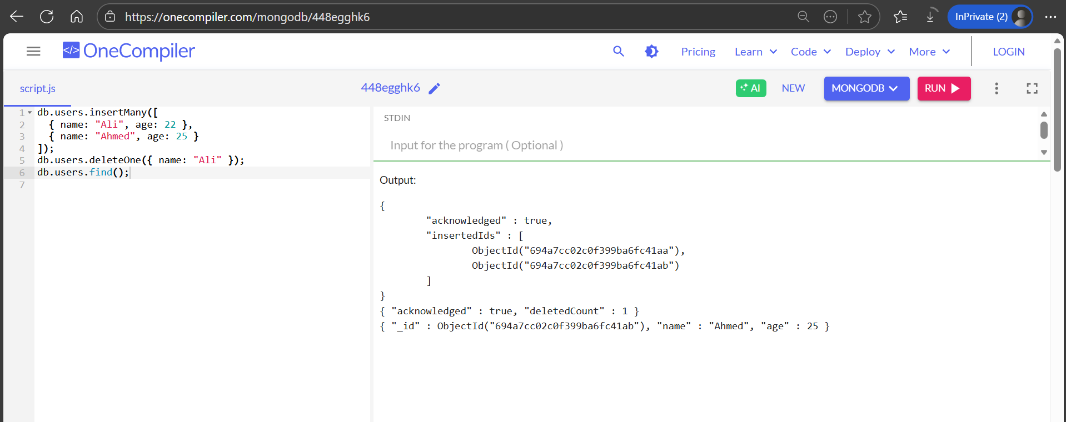

Q17. Remove one product with a specific productId.
db.products.deleteOne({ productId: 201 });

7. DeleteMany (Practical)
Q18. Delete all users from a particular city.
db.users.deleteMany({ city: "Delhi" });

Q19. Delete all records where the year is less than 2020.
db.students.deleteMany({ year: { $lt: 2020 } });

8. Drop Operations (Practical)
Q20. Drop a collection named students.
db.students.drop();

Q21. Drop the current database.
db.dropDatabase();
Thank You!

